BIRLA INSTITUTE OF TECHNOLOGY AND SCIENCE

PILANI (RAJASTHAN)

Practice School Division

Station: **Jaipur Metro Rail Corporation**

Centre: **Mansarovar, Jaipur**

Duration: **55 days** Date of Start: **23rd May 2016**

Date of Submission: **11-07-2016**

Title of the Project: **Station Maintenance Monitoring System**

ID No. **2014A2PS480P**

Name **Hritik Soni**

Discipline **Civil**

Name of Expert **Mr. Suyash**

Designation of Expert **JE at Station/Viaduct (Works) O&S Department**

Name of PS Faculty **Ms. Sunita Singhal**

Key Words: **Maintenance System, Java FX, Digitalization,**

**Software, Station Maintenance, Jaipur Metro**

Project Areas: **Software Development, Maintenance System**

Abstract:

The Project is aimed to make a maintenance monitoring system for the stations of Jaipur Metro. It Digitalizes the existing maintenance system and eliminated the need of paperwork to a large extent. It uses the power of Java and uses the Java FX libraries for the GUI. The information is stored securely inside MySQL databases and the software is protected by a Reliable Login System. The interface of the System is very easy to use and most things can be done without much clicking. Its main purpose is to show and save inspections done and give notifications as needed.

Signature of Student Signature of PS Faulty

Date

**A REPORT**

**ON**

**STATION MAINTENANCE**

**MONITORING SYSTEM**

**BY**

**HRITIK SONI**

**2014A2PS480P**

**Civil (Official)**

Prepared in partial fulfilment of the

Practice School I Course

AT

Jaipur Metro Rail Corporation, Jaipur

A Practice School I Station of

**BIRLA INSTITUTE OF TECHNOLOGY AND SCIENCE, PILANI**

**(June, 2016)**

**Table of Contents**

1. Introduction
2. Discussion
3. Conclusion

**INTRODUCTION**

The Project is aimed at making a Maintenance Monitoring System for the Station of Jaipur Metro. Its purpose is to make a software that would digitalize most of the paper work and provide ease to the supervisors in searching, etc. and hence maximize efficiency.

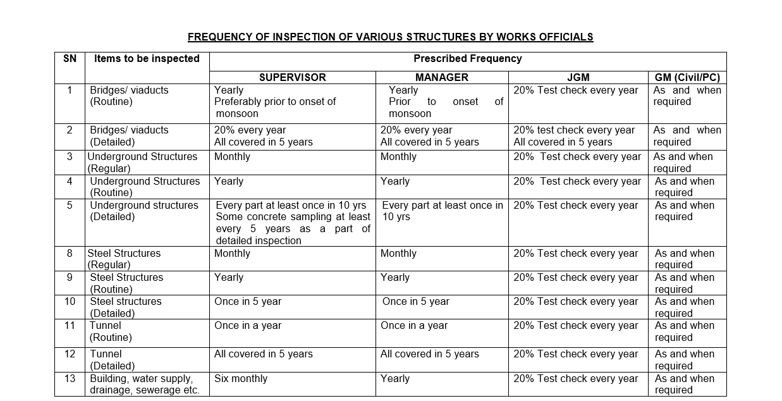**Inspections:** Inspections are activities that are performed on a frequency basis to check for defects, proper functioning, etc. For every type of Structure track, Station, Viaduct, there are several inspections so as to verify if everything is correct. Here is a Schedule of Inspections.

**DISCUSSION**

This software is only meant to take care for Station based Inspections. Each inspection has to be done according to the above schedule and accordingly for inspections with flaws, maintenance has to be scheduled. The software aims to keep a record of all the inspections, notify for upcoming inspections, notify for rectified and non-rectified flaws, keeping proper security and most importantly providing user all he needs to make his life easier. The user friendliness of the software has been taken in mind and accordingly the design and interface is made.

**Explanation of Tools used to develop the software:**

1. **Java**: The Power, Reliability and Platform Independence of Java has been used in this software. This was chosen mainly because of its popularity and all of the things that can be done in this language without much effort. Also, the nature of the language for being object-oriented empowers the user to use the object model for keeping a real-life touch with each of the elements of the interface and rest of the software.
2. **Java FX:** Unlike swing, it is a graphics add-on library that uses the xml like behaviour to keep record of all the elements on a GUI screen. In most other terms, it fulfils all purposes that can be filled used swing. In terms of visuals, Java FX has much better controls and the library uses complete power of the Operating System as it is closer to the operating system in terms of interfacing. It also provides the ability of using CSS on each of its elements.
3. **MySQL:** The choice of databases over files is obvious – Security, Reliability and Blah Blah, but the reason of choosing MySQL over other database systems is not anything particular. It just happens to be that I’m more familiar to MySQL than anything else and chose it.

The next section is going to explain the software and provide visuals for better understanding.

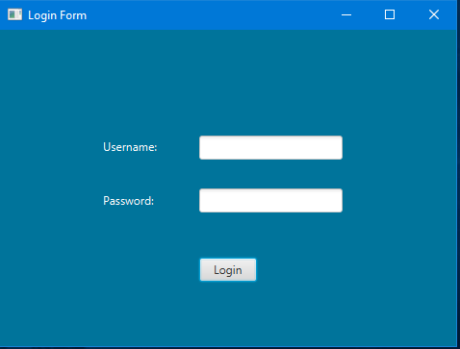

The above picture shows a simple login form which will be modified on the basis of the requirements of the my JE as he analyses my software further. All of the information is interfaced with MySQL and protected in all ways. It leads to an Inspection selection screen as shown on the next figure.

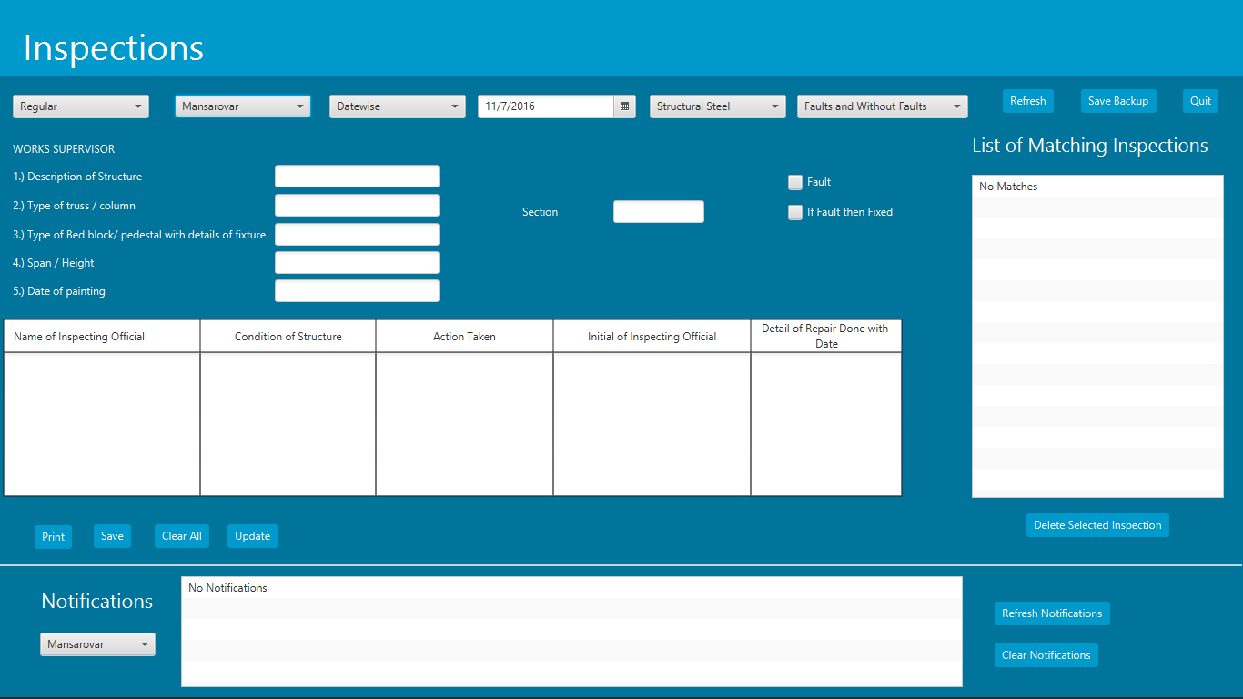

The Inspection Selector shown on the right is meant for the ALL-IN-ONE software screen. It contains everything basically on a single screen. It has elements like frequency chooser, fault mechanism handler, etc. that are very powerful in implementing search mechanisms. Also buttons like Save Backup, Print, Save, Update, etc. make the software even more powerful in its final form.

Explanation of each of the control is provided underneath:

1. **Station Selector Combo Box:** This combo box is meant for the user to select the station for which he wants to see/enter the information. All 9 of the currently usable stations are among its choices.
2. **Select Date – Date Picker:** This Date picker is meant to switch the date so that the inspection form of that particular date is shown underneath with all the required information if it were entered before.
3. **Inspection Selector Combo Box:** This combo box has all the relevant inspection types that are related to Station Maintenance. Every Inspection type has its form that is shown underneath in the Form Scene.
4. **Form Scene:** In this scene all of the forms will have their existence. The type of form shown will depend upon what is selected in the Inspection Selector Combo Box. It is this place that most of the controls like text fields, text areas, labels, etc. are used and containers like grid pane, vboxes, hboxes, etc. are used to align these controls.
5. **Button Bar:** At the bottom of the screen is a button bar that has some buttons like Save, Clear All, etc. At the moment, only Save has been added but in the future development of the program, more will be added.

**ADDITIONAL IMPLEMENTATIONS**

1. The Mechanism of access rights is maintained and thought of but it hasn’t been implemented because I haven’t received any information from the organization about its necessity.
2. Frequency Selector combo box has been added from which user can select the frequency of a particular inspection for insertion/retrieval. Buttons were not used because they take up a lot of space.
3. Full Screen Mode: The default mode of opening the inspection selector is set to full screen mode. This allowed use of a lot of controls on the same screen and aesthetically it looks a lot better.
4. Date Requirement Changer Combo Box: This Combo box has options – ‘Datewise’, ‘Monthwise’ and ‘Yearwise’. These are ways of fetching information into the Match List. Datewise picker is the default choice, it shows only the datepicker. The Monthwise option hides the datepicker and makes two additional combo boxes visible namely Month-Monthwise and Year-Monthwise. Here user can choose to see a list of inspections done in some month of some year. The Yearwise option hides the datepicker and the monthwise combo boxes and make a new combo box visible namely Year-Yearwise. The user can choose a year from this combo-box to see a list of inspection done in that year.
5. Fault Selector: The fault selector combo box has options to show those inspections which have resulted into faults, or those without fault or both.
6. Refresh Button: This button manually fires the internal update event which refreshes the list based on the currently selected search filters. This isn’t required as the filters automatically fire an update event upon a change.
7. Fault an IfFaultThenFixed checkboxes: These checkboxes are added to all inspection forms so as to mark inspections if they have resulted into a fault and if they did they can be searched and later marked for a faultFixed marking.
8. Match List: This list shows all inspections as per the various choices selected in the inspection filters. It has an internal change listener which is activated whenever a new item is selected, a change event is fired which updates the inspection contents in the inspection form.
9. Delete Inspection Button: This Button is used to delete the selected item in the match list from the database so it is entirely removed.
10. Notification Center: This List View is used to show any general notification like Inspection saving, deleting, etc. and also notifications like when to do next inspections and its entry data inside the software. Additional Buttons like Refresh and Clear have been added to make ease of the user. Also a combo box for station chooser is added beside the notification list view so as to see only those notifications which are meant for that particular station.

**CONCLUSION**

I conclude the report by summarizing the results. The Project is pretty much ready for use but still changes might be done as per the requirements of the JE. I hope that this software will prove useful to the organization as a whole by minimizing paperwork saving money, paper and time.